**KWANTLEN POLYTECHNIC UNIVERSITY**

# INFO 2416

**Project Part 4**

Part 4 TBA

**Group Members**

Ravjot Singh 10042834 Gourav 100429487 Divya 100426997

Orbitational units

OU of Business dept

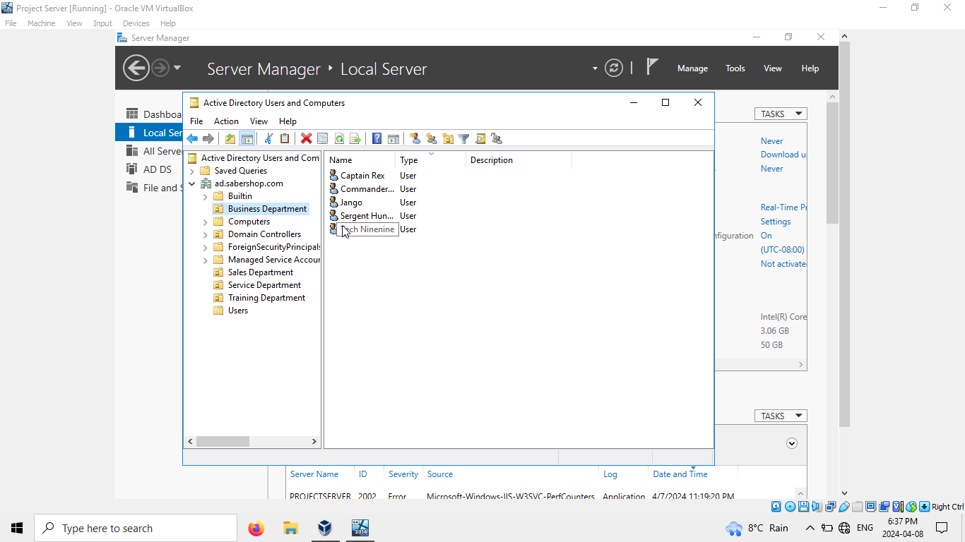

OU of Sales dept

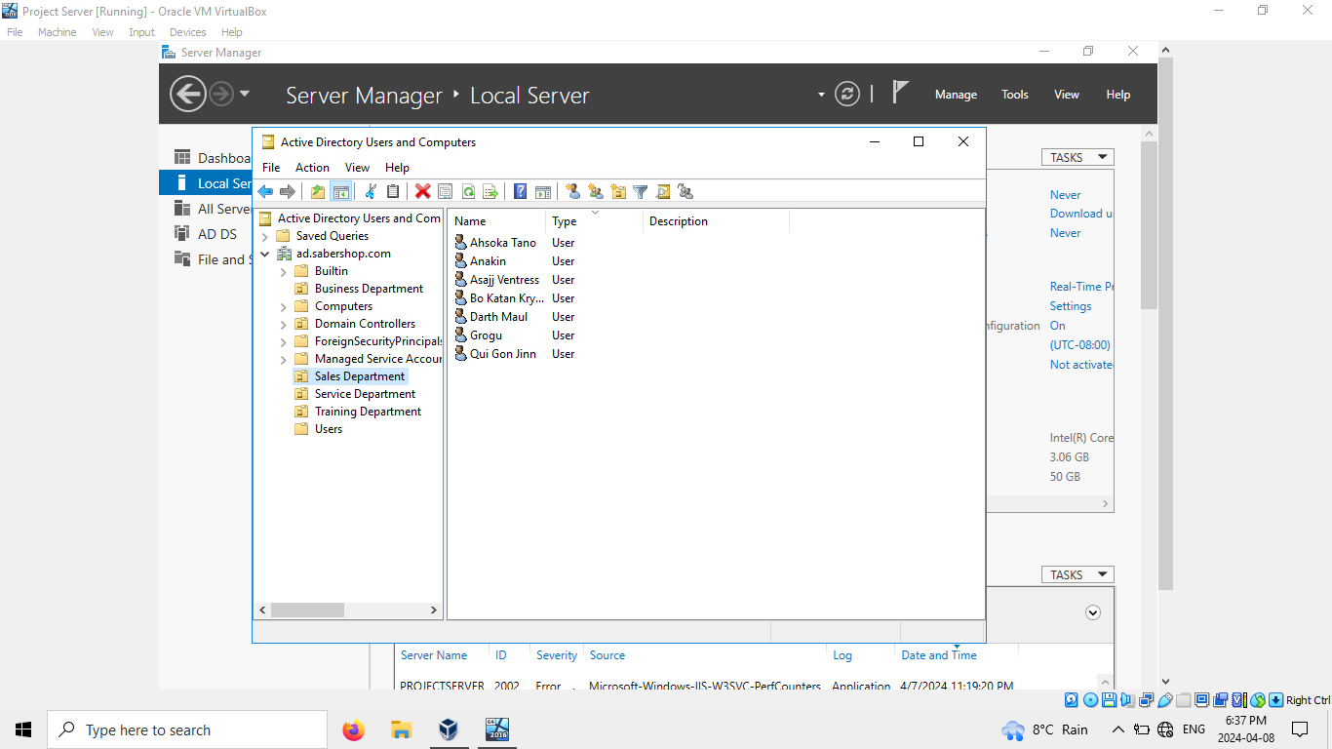

OU of Service dept

OU of Training dept

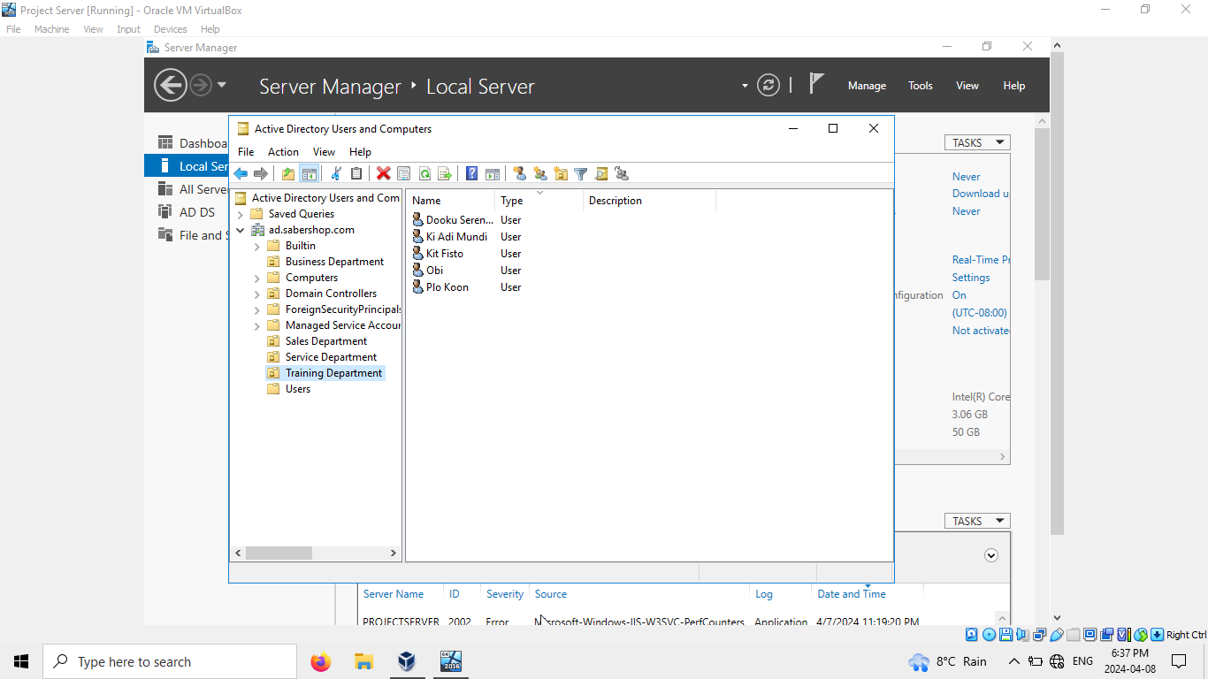

Folder Redirection

Web page and advance setting

To deploy:

To deploy this system in real life extensive planning is required to make sure that the server and its services meet the organisation requirement. This includes hardware, software, printers, computer, security, and network infrastructure which was discussed in part 1. Once that is done the window server 2016 is configured according to plan which include creating users, accounts, workstations, OU’s, linking GPO’s, configuring permissions, folder share and finally a domain to be set up to manage all the user and OU’s. After this step testing should be done to make sure that all the infrastructure is working properly computers, servers, domain, and printers. At last, user training and documentation should be provided to employees to learn and get familiar with the functioning of their workstations.

Project Reflection:

In this project we learned a lot about the window server 2016 how it works and practised most important services like GPO, OU’s, and Active directory. This helped us a lot to understand how window server and its services work in a day-to-day life of any business. In this project we did not find anything particularly difficult but there was something challenging when we were installing IIS service at one point it showed that the server did restart, after some research we found that the server was shut down during installing of IIS but not starting up again so we used command prompt and used ‘iisreset’ command and it started the server again.

In part 1 we learned about the hardware and software required for a business and it’s cost. In part 2 we designed the Active directory part of the project OU’s and users along with permission for all the users and shared folder, in part 3 we implemented those plans and created the users and share permissions. In last part we created OU’s and added user, and linked GPO to those OU’s and set up a web page and used advance setting of IIS web service.